**A REPORT**

**ON**

**Implementation of Digital Design and Microprocessor based Systems**

**Using Simulation Techniques**

PREPARED BY

Name of Student ID. No.

Abhilash Jain 2010A8PS303P

Sanket . D. Bahalkar 2010A8PS321P



**BIRLA INSTITUTE OF TECHNOLOGY & SCIENCE, PILANI**

**29TH October, 2012**

Proteus ISIS



**About Proteus:**

The Proteus Design Suite is software package, developed by **Labcenter Electronics** for making a complete electronics design system. The package includes **ISIS** (for schematic capture), **PROSPICE** (for circuit simulation), **ARES** (for PCB design) and **VSM** (for simulation of embedded software for popular micro-controllers).

In this tutorial, we are going to learn designing of some basic electronic circuits involving 8086 Microcontroller using ISIS.

**ISIS** (**I**ntelligent **S**chematic **I**nput **S**ystem):

ISIS combines an exceptionally powerful design environment, with the ability to control most aspects of the drawing appearance, in terms of line widths, fill styles, colors and fonts. We will be dealing with the design of circuits using ISIS.

**Placing Components on the Schematic:**

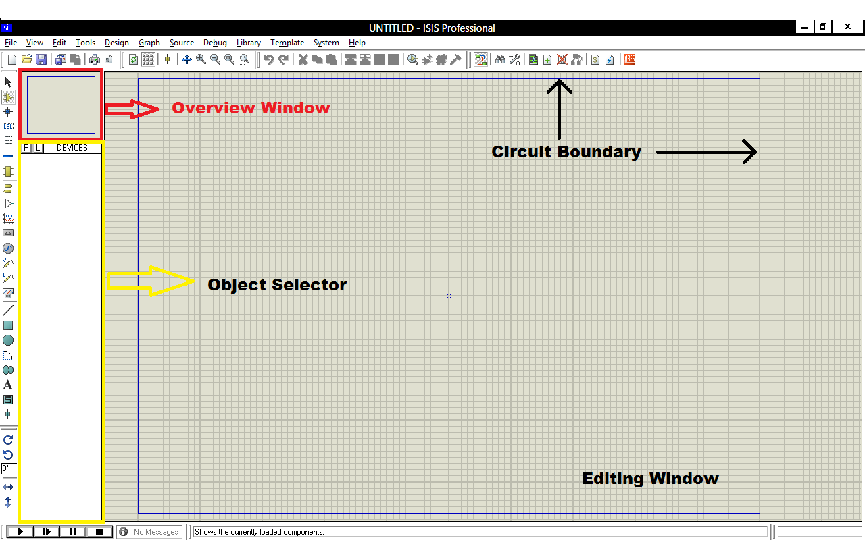Once ISIS is opened, a window with an empty grey area is visible (generally, gridded). This area is our drawing space and is called the *Editing Window*, where the circuit will be build (the blue line represents the boundary of the circuit area). The bar on the extreme left of the window contains different mode of operation of the circuit. Attached to the right of this bar is the *device/object**selector*, which is used for selecting the components (or devices) that will be used in making the circuit. On top of this device selector is a small square area, called the *Overview Window*, which displays a complete overview of the circuit.

To add a device to the circuit, click on the small square button labelled “**P**” (pick from libraries), or press “**P**” on the keyboard (you can also add a device by just right clicking on the editing window and then selecting **Place > Component > From Libraries**). A new window, entitled “**Pick Devices**” is opened. On the top-left corner of this window, a text-box labelled “**Keywords**” is present. Type the name of the device, or the IC number, that is to be placed on the circuit in this text-box. A list of devices is displayed in the “**Results**”column, with a brief description of the corresponding device. Also, the “**Schematic Preview**” and the “**PCB Preview**” are shown, if available, on the right of the window of the selected component or device (these previews are the diagrammatic representation of the particular component or device that is selected).

Here, we will have selected IC 7440, which is a dual 4-input NAND gate IC. The schematic model shows how will device look when placed in the editing window, whereas the PCB preview shows an accurate representation of the actual 7440 IC, with dimensions.

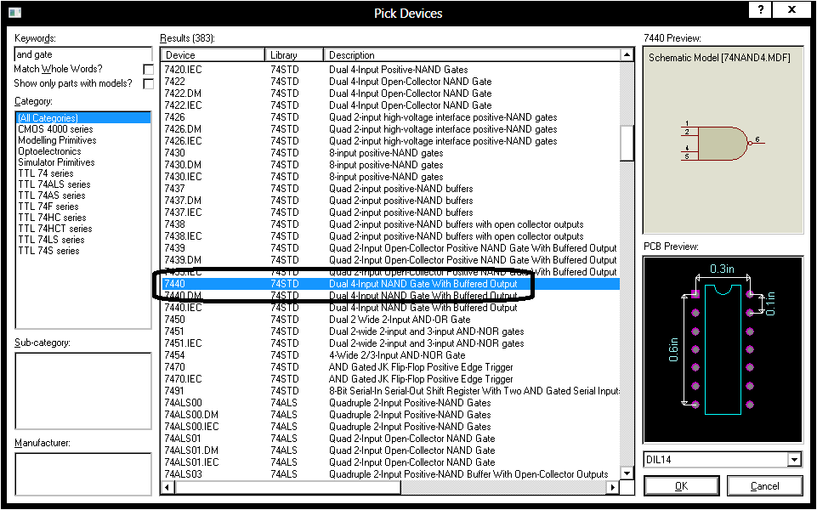

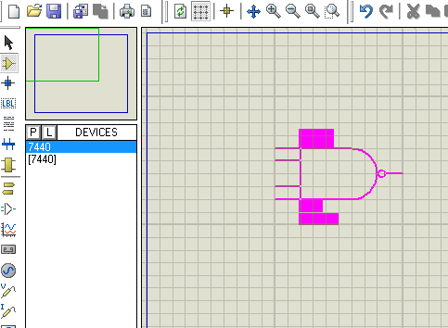To pick a device, select it from the list and then click on OK. After picking a device, it is also displayed in the device selector, from where we can place it on our circuit. To place a device on the circuit, just select the component that is to be placed from the device selector, and then bring the mouse pointer to the editing window. **Click once** on the schematic. The mouse pointer now changes to a stencil of the device that you selected (called the *placement mode*). To place it on the circuit, just take the pointer to the desired location and then click again.

Here, we have added the previously selected IC 7440, and are in the placement mode to place it on the schematic.

**Note:** To zoom in and out of the circuit, just scroll up and down. To pan across the circuit, use middle click, or left click on the overview window.

**Wiring up the Circuit:**

ISIS does not have a separate wiring mode, and is by default in the wiring mode, which makes it pretty fast and easy to wire up a circuit. To place a wire between any two pins, just take the mouse pointer to one pin. The pointer changes to a green pen, which means that a wire can start from (or end at) that point. Left click once and then take the mouse pointer to the other pin where the wire ends. Click again to place the wire between the two pins.

The wire will be placed automatically by the “*wire auto-router*”, along the grid lines, but if you want to place the wire manually, then just click on the spot where you want the wire to be placed (Note: The wire can start and end at a pin only. No wire can be left floating).

To place a wire onto an existing wire, the procedure is almost identical but note that a connection cannot directly start from an arbitrary point on a wire (start the connections from the pin and terminate them on the wire). When you terminate the connection on another wire a junction dot will be placed automatically to complete the connection. If, during a design, you want to make a wire-to-wire connection you must first place a junction dot on the wire and then wire from the junction dot to the other wire. A placed wire can be *dragged* or moved to adjust its position at any time.

**Terminals Mode:**

To place terminals, start by selecting the *Terminal Mode*; this will switch the Object Selector and provide us with a listing of the available terminal types. Some of the terminals are Input terminal, Output terminal, Power and Ground. The basic use of a terminal is to make a connection between two points, without placing a wire between them. For example, if you want to connect two pins, place an output terminal on one of the pins, give it label (or name). Then place an input terminal to the other pin, and give it the **same label** as the output terminal you placed before. This makes a connection between the two pins. (The terminal can be given any name, but giving it a relevant name makes the schematic more legible and easy to understand.)

A terminal can also be placed by right clicking and selecting **Place > Terminal** and then the type of terminal you want to place.

**Placing a Power Source:**

To place a power source, go to the *Generator Mode*. The object selector now displays a list of the generators that can be used. You can place a DC, sine, pulse and many other types of voltage sources.

To set the DC voltage of a voltage source, first place it on the schematic, then **double-click** on it (this displays the device properties). You can set the different parameters – source name, voltage value, frequency of the wave, duty cycle, etc. - for the voltage source here.

You can also place a power source by right clicking and selecting **Place > Generator** and then selecting the type of generator.

**Virtual Instruments:**

ISIS provides us with some basic instruments to take real-time readings of current or potential difference or any other quantity that we want to measure. To place a virtual instrument, go to the *Virtual Instruments Mode,* and then select the type of instrument you want to place from the object selector. These instruments will show readings when the schematic is running.

You can also place an instrument by right clicking and selecting **Place > Virtual Instrument** and then selecting the instrument.

**Logic States:**

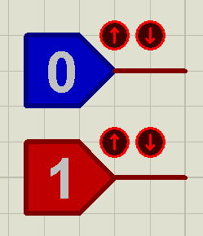In digital circuits, we work with 0’s and 1’s most of the time. A very simple way to represent these logic states in ISIS is by using *Logic* *States*. To add a logic state to your circuit, the procedure is similar to placing any other device. Just enter the keyword as “logic state” in the Pick Devices window.

The diagram shows how two (one in the high state, and one low) latched-type logic states look on a schematic. The state can be changed just by left-clicking on the device itself, or on the encircled arrows on the side of the device.